Difference between JDK, JRE and JVM

1. [Brief summary of JVM](https://www.javatpoint.com/difference-between-jdk-jre-and-jvm)
2. [Java Runtime Environment (JRE)](https://www.javatpoint.com/difference-between-jdk-jre-and-jvm#jre)
3. [Java Development Kit (JDK)](https://www.javatpoint.com/difference-between-jdk-jre-and-jvm#jdk)

We must understand the differences between JDK, JRE and JVM before proceeding further to [Java](https://www.javatpoint.com/java-tutorial). See the brief overview of JVM here.

If you want to get the detailed knowledge of Java Virtual Machine, move to the next page. Firstly, let's see the basic differences between the JDK, JRE and JVM.

JVM

JVM (Java Virtual Machine) is an abstract machine. It is called virtual machine because it doesn't physically exist. It is a specification that provides runtime environment in which java bytecode can be executed. It can also run those programs which are written in other languages and compiled to Java bytecode.

JVMs are available for many hardware and software platforms. JVM, JRE and JDK are platform dependent because configuration of each [OS](https://www.javatpoint.com/os-tutorial) are different from each other. But, Java is platform independent. There are three notions of the JVM: *specification*, *implementation*, and *instance*.

The JVM performs following main tasks:

* Loads code
* Verifies code
* Executes code
* Provides runtime environment

[More Details...](https://www.javatpoint.com/internal-details-of-jvm)

JRE

JRE is an acronym for Java Runtime Environment. It is also written as Java RTE. The Java Runtime Environment is a set of software tools which are used for developing java applications. It is used to provide runtime environment. It is the implementation of JVM. It physically exists. It contains set of libraries + other files that JVM uses at runtime.

Implementation of JVMs are also actively released by other companies besides Sun Micro Systems.

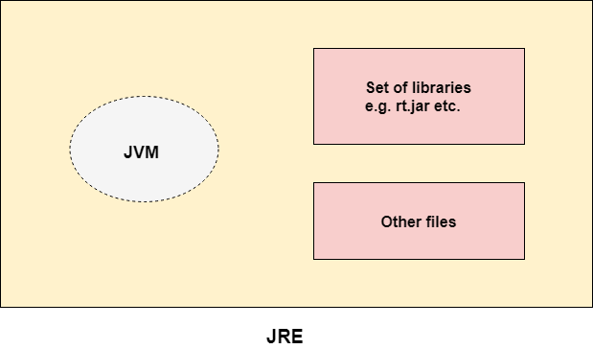

JDK

JDK is an acronym for Java Development Kit. The Java Development Kit (JDK) is a software development environment which is used to develop java applications and [applets](https://www.javatpoint.com/java-applet). It physically exists. It contains JRE + development tools.

JDK is an implementation of any one of the below given Java Platforms released by Oracle corporation:

* Standard Edition Java Platform
* Enterprise Edition Java Platform
* Micro Edition Java Platform

The JDK contains a private Java Virtual Machine (JVM) and a few other resources such as an interpreter/loader (Java), a compiler (javac), an archiver (jar), a documentation generator (Javadoc) etc. to complete the development of a Java Application.

